SGD
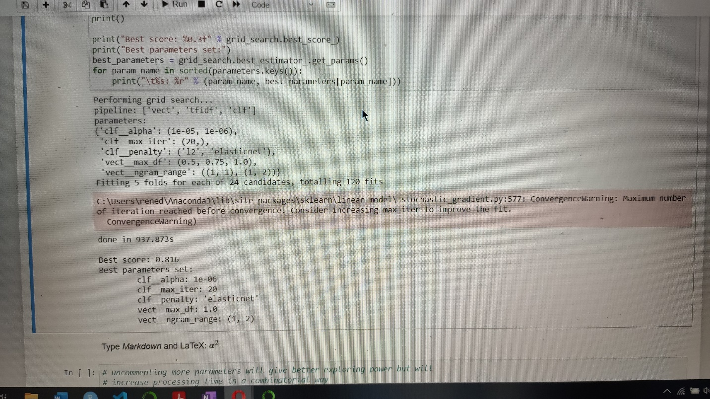
Best score : 0.816 (not sure of n size, probably 100.000 or 640.000)
N= 640.000
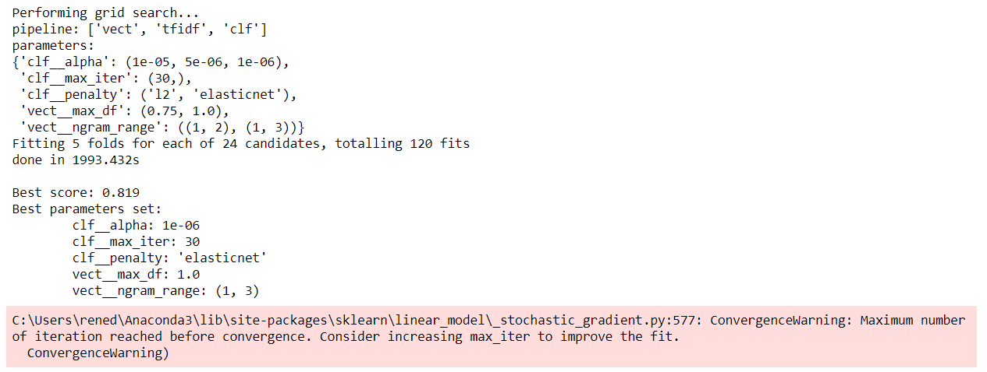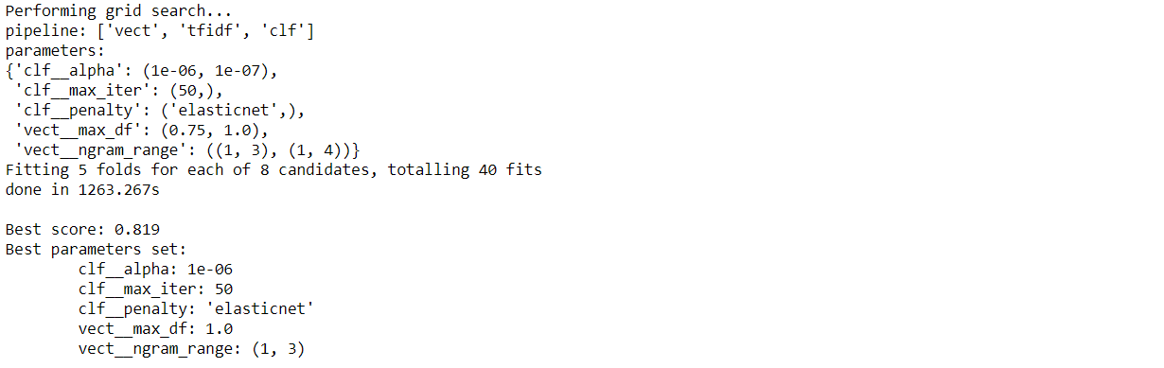
N = 10.000
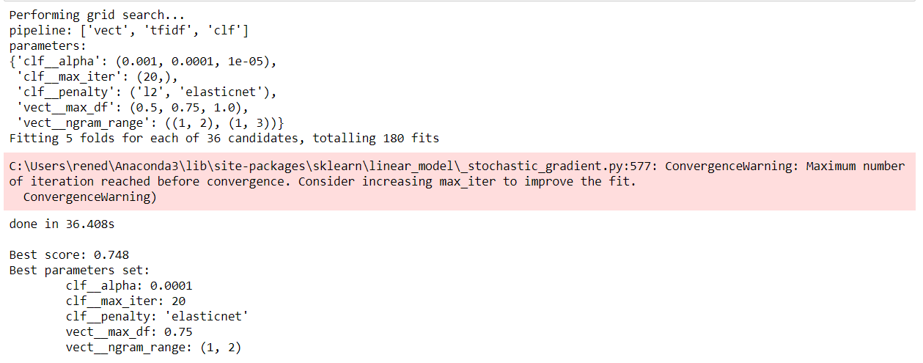

N = 50.000
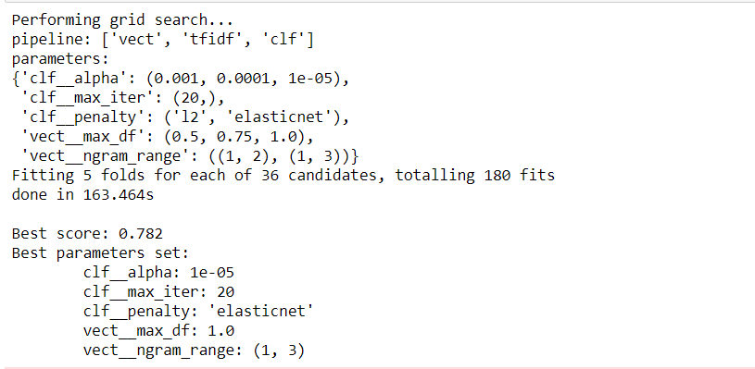
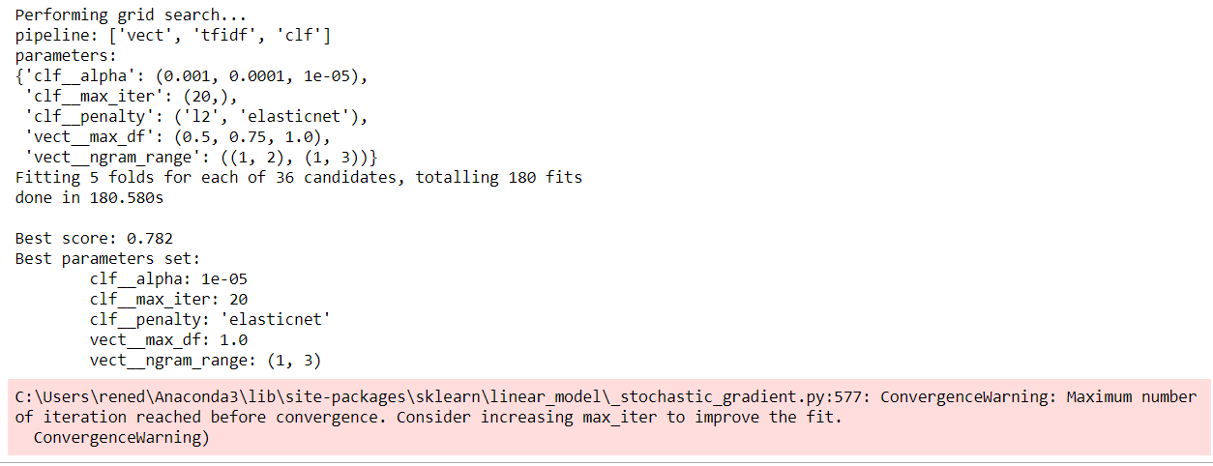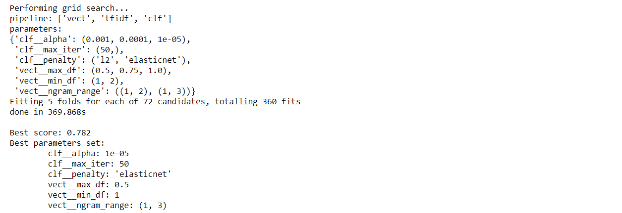
MNB

N = 100.000
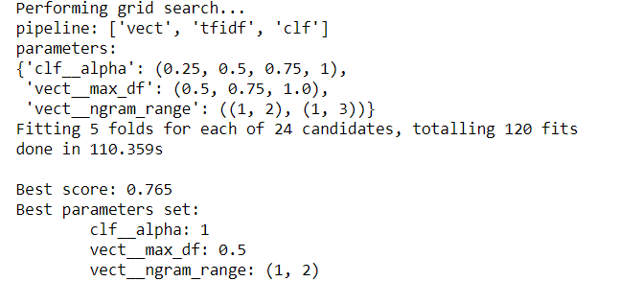
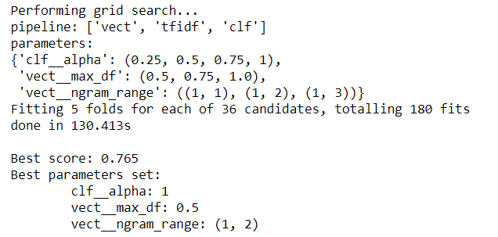

Logistic Regression
N = 50.000
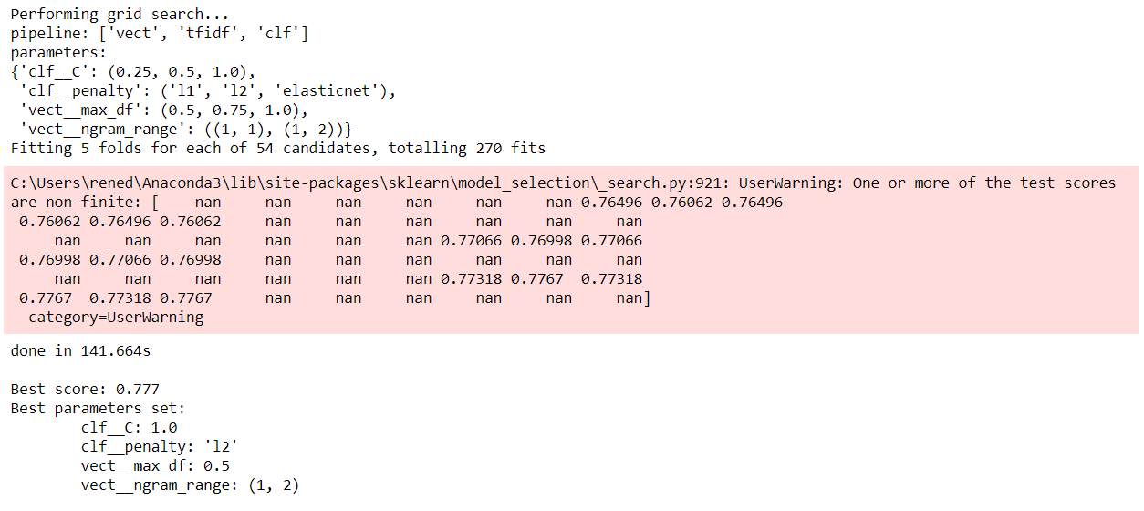
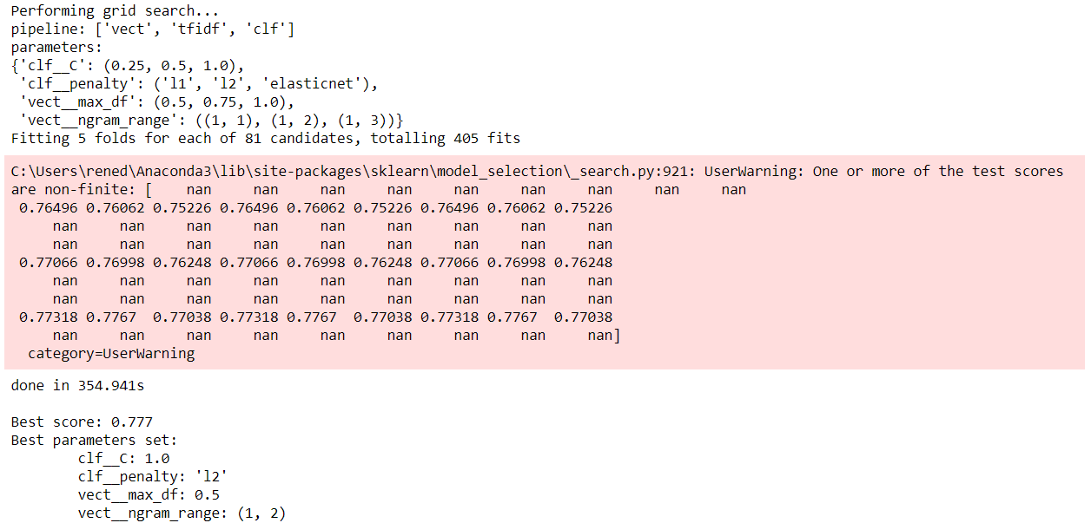

Random Forest
N = 10.000
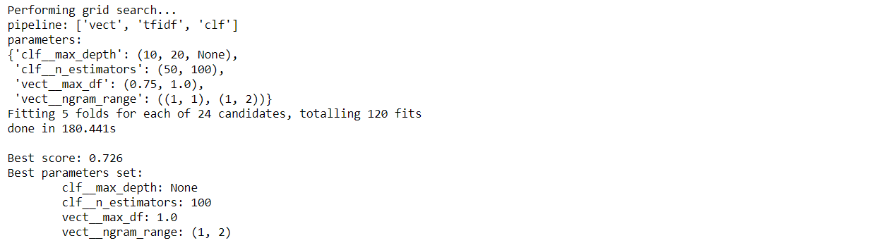
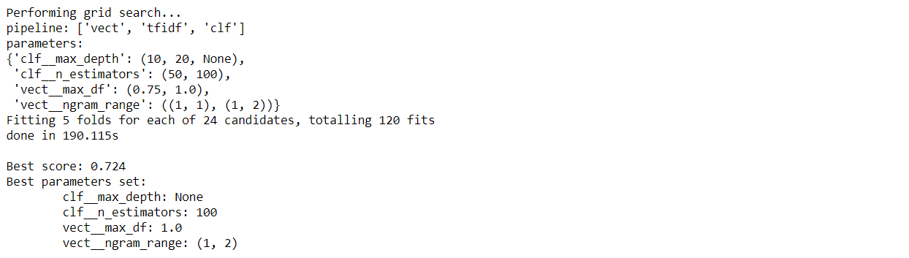
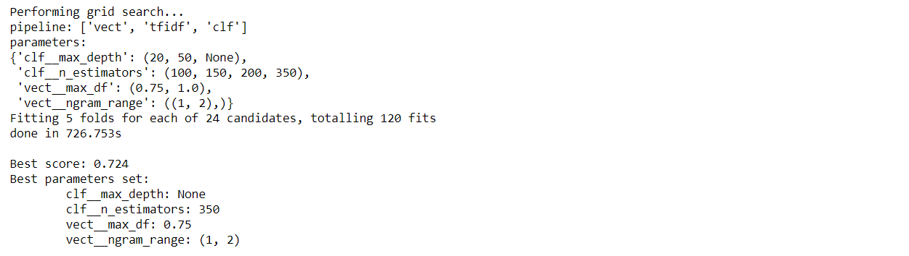

N = 50.000
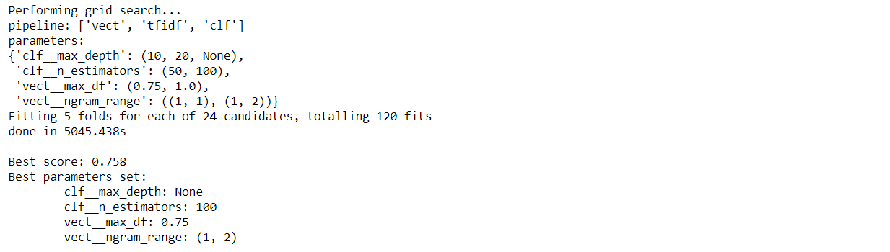

SVM

N = 50.000
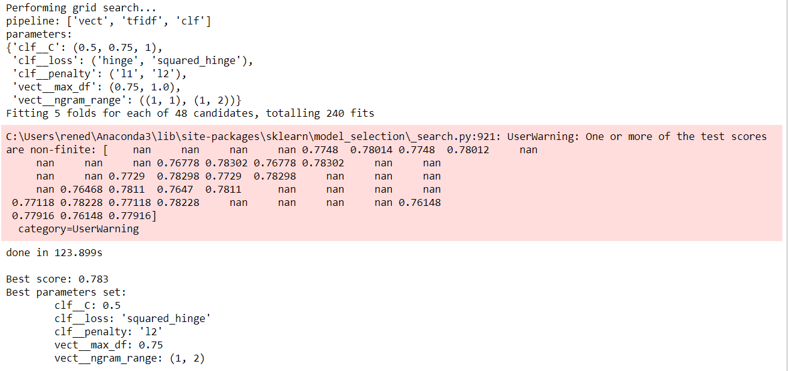
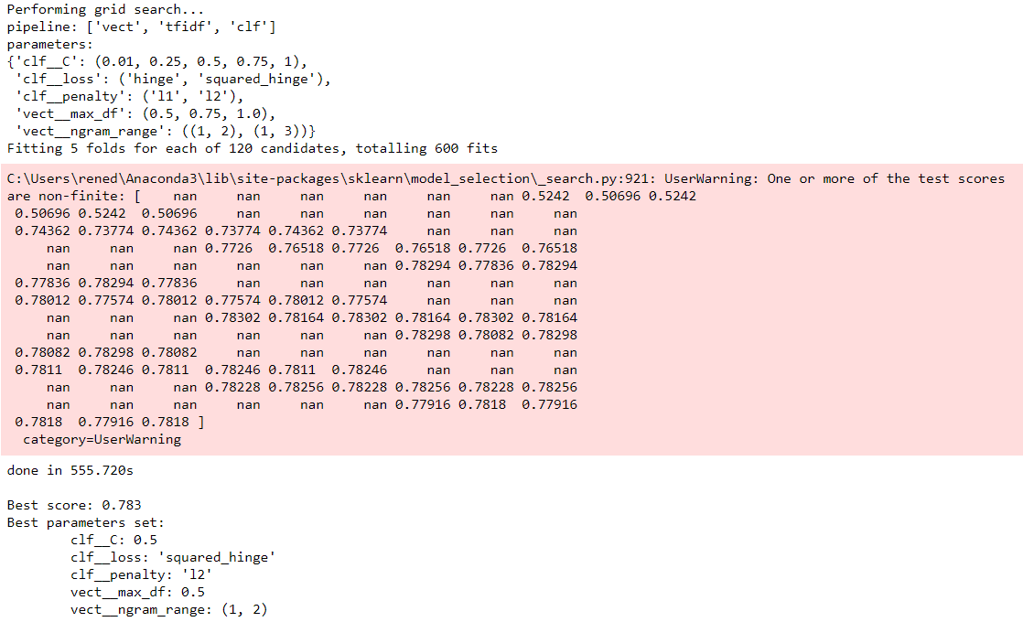

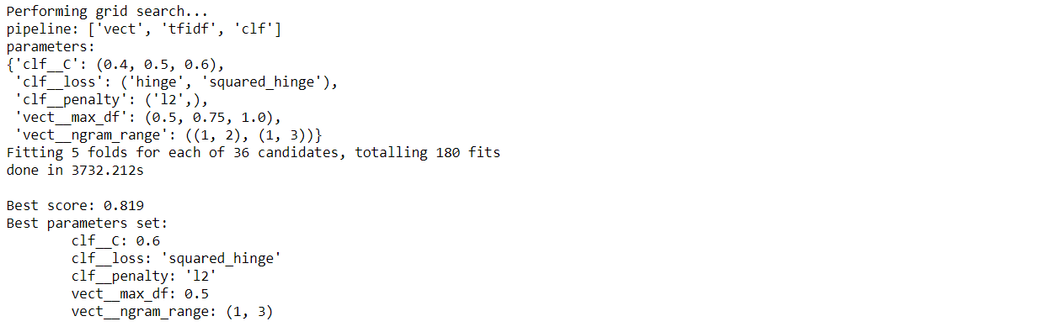

N = 300.000
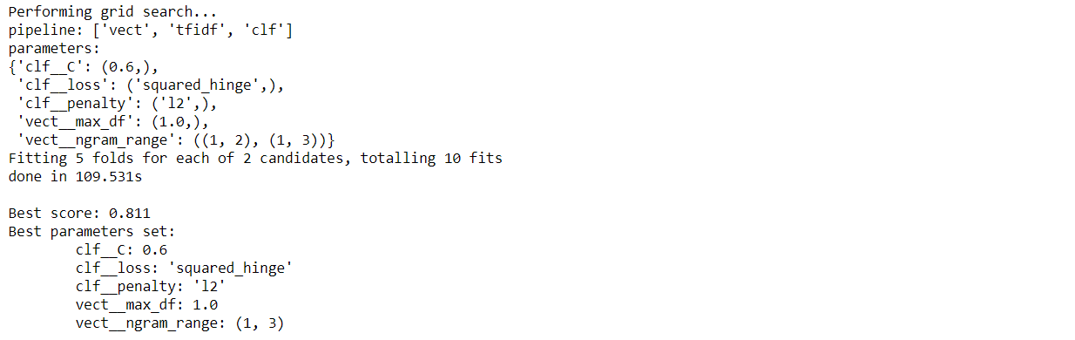

Without the 5 determinant
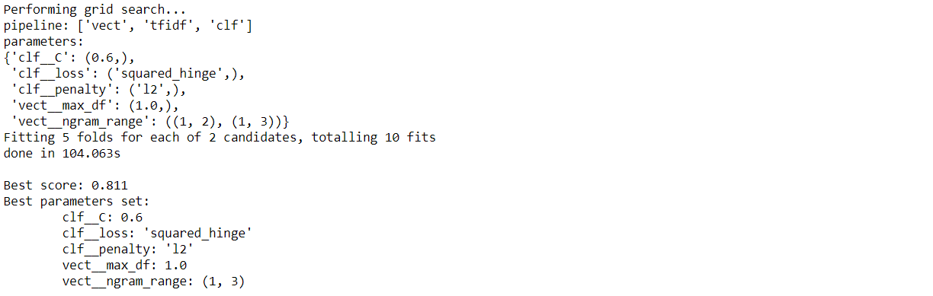
Without ‘english’ -> BAD
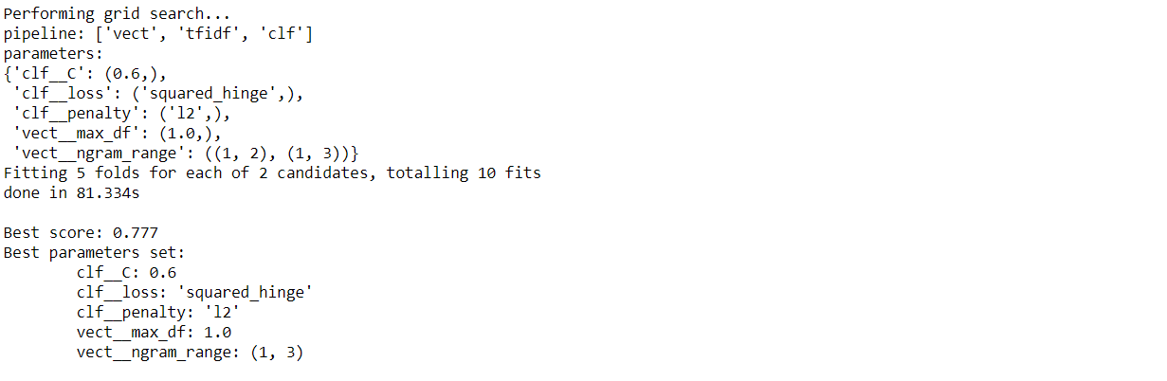

N = 320 000 without usernames
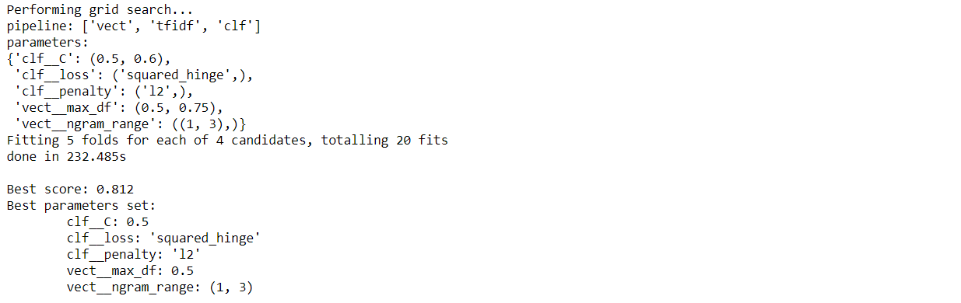
N = 320 000 with usernames
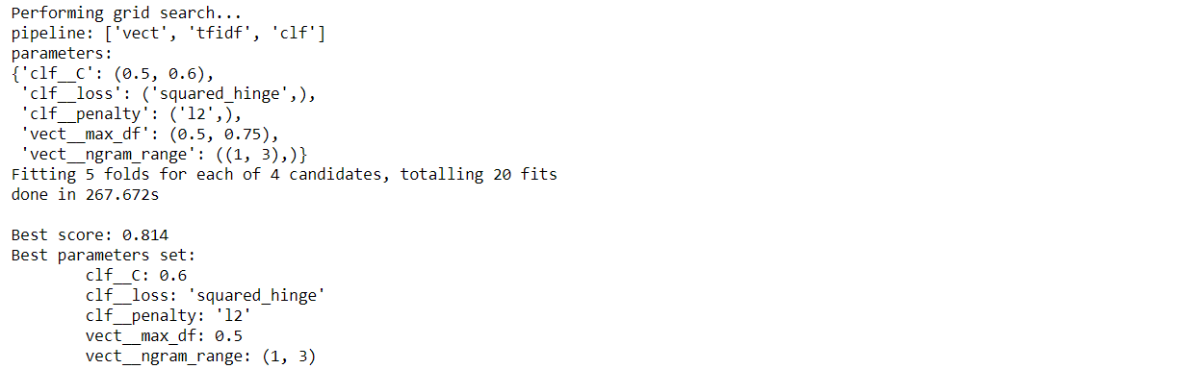

N = 640 000 (?) with user
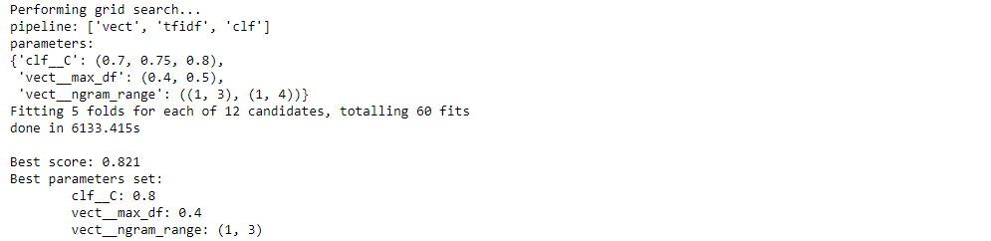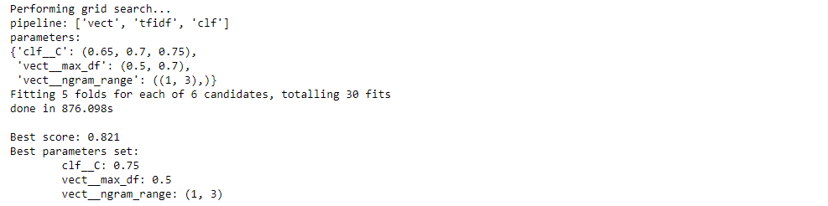
N = whole dataset, emote.text + emote.user
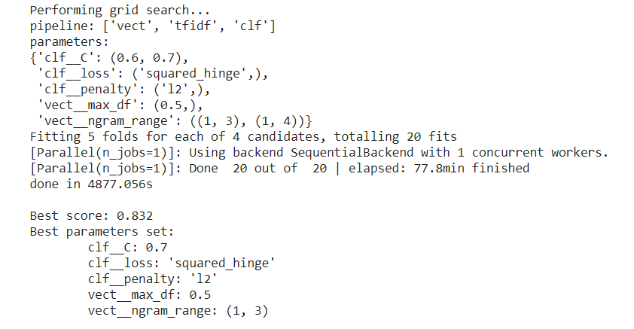
C = 0.7,0.75,0.8 ; max_Df = 0.4, 0.5 ; ngram_range = (1, 2), (1, 3)
CHOICE == 0.7 ; 0.4 ; (1, 3)
BEST SCORE = 0.827

CNN
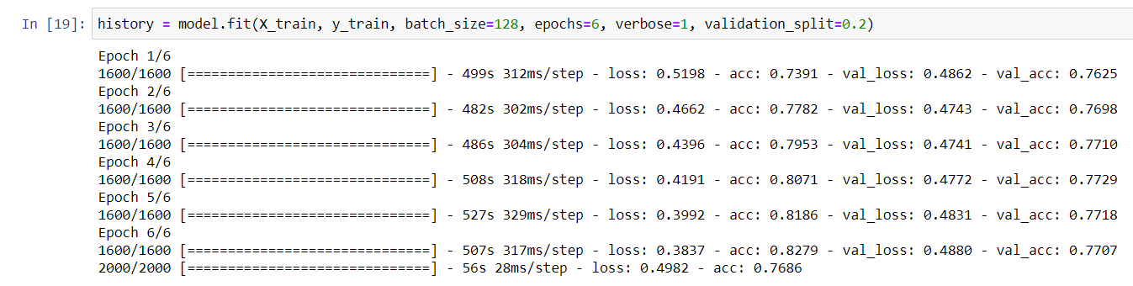
Maxlen 100, numwords = 5000
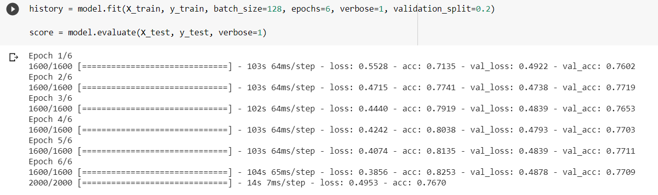
Maxlen = 1000, numwords=500000 WORTH
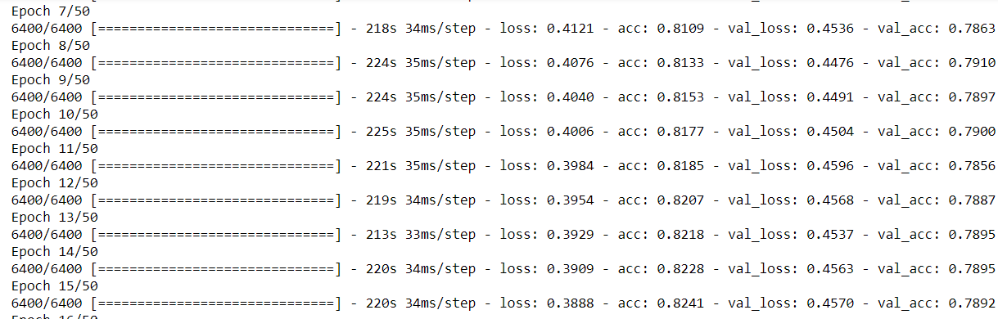

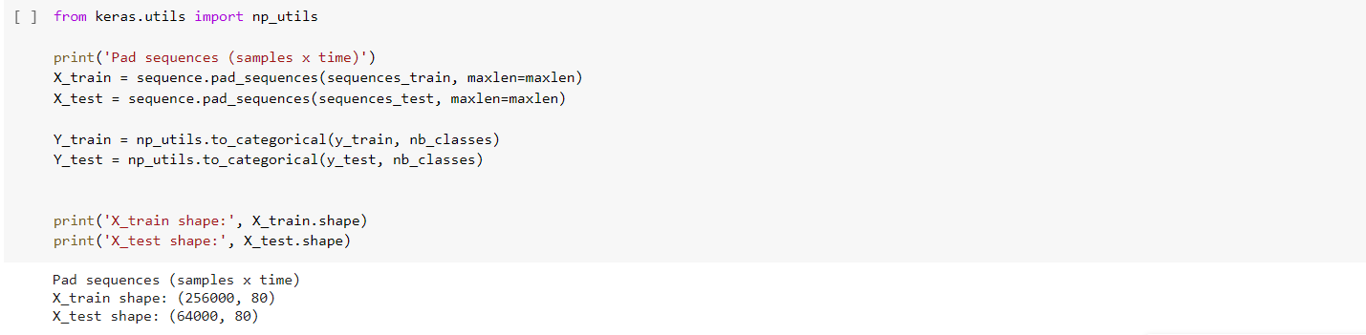
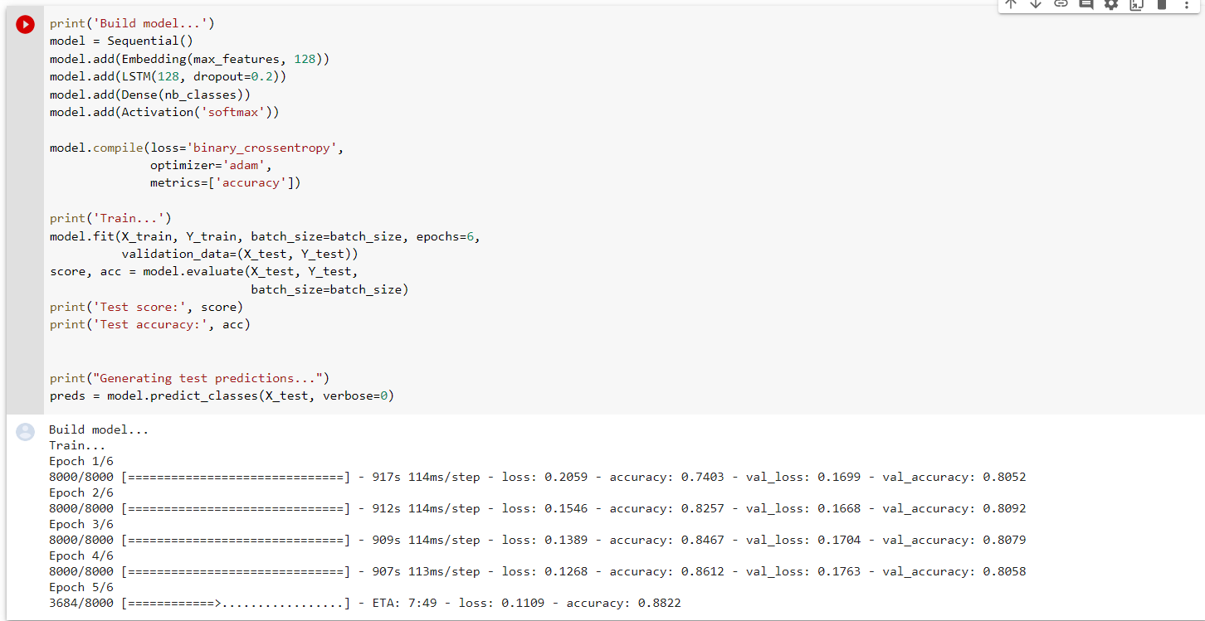

LSTM
Full data without user (20% test)
